# ProtoBuf:

Method of serializing structured data. It is useful in developing programs to communicate with each other over a wire or for storing data. Better than Json in terms of size. Protocol buffers are Google's language-neutral, platform-neutral, extensible mechanism for serializing structured data – think XML, but smaller, faster, and simpler.

Why Not JSON:

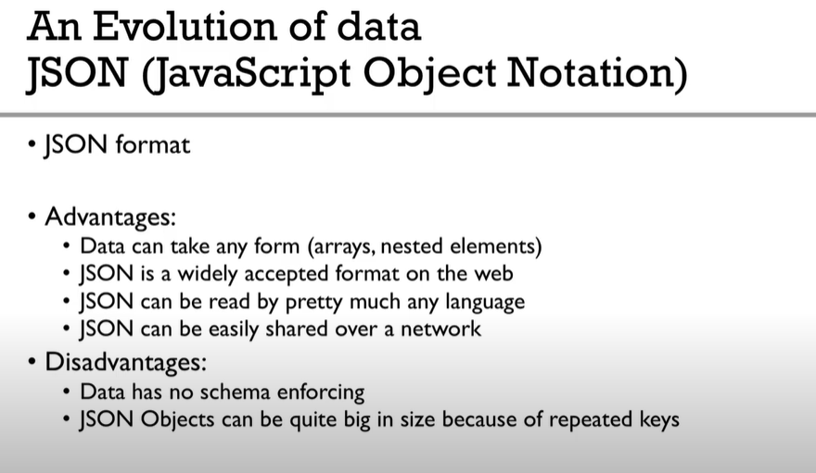

Why Protocol Buffers

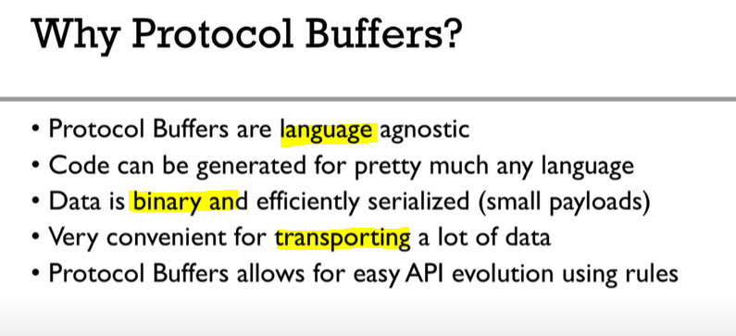

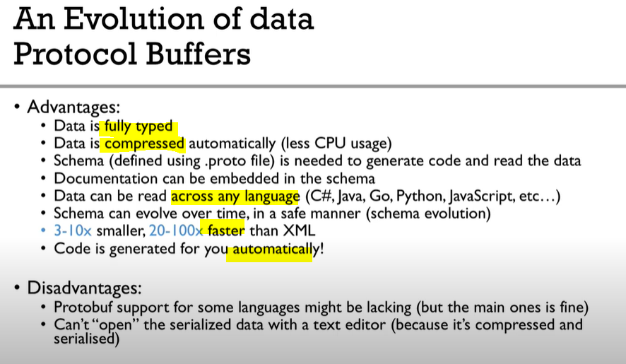

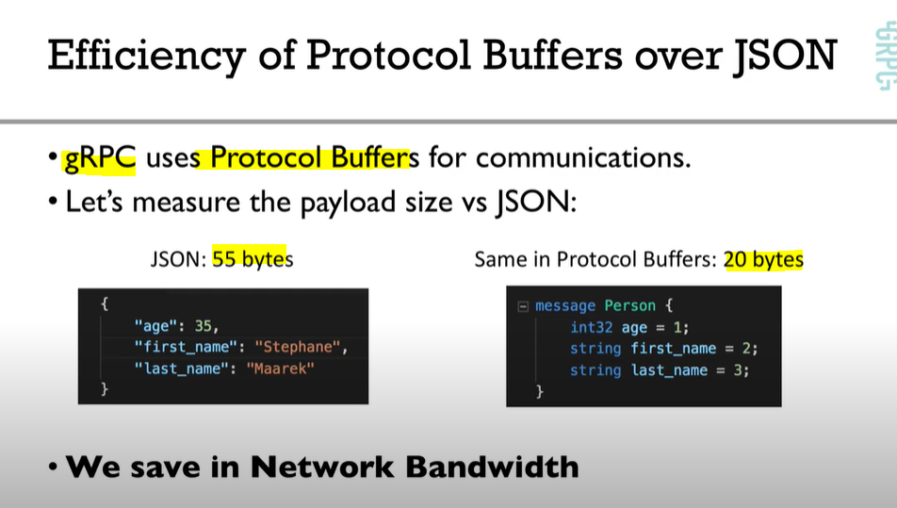

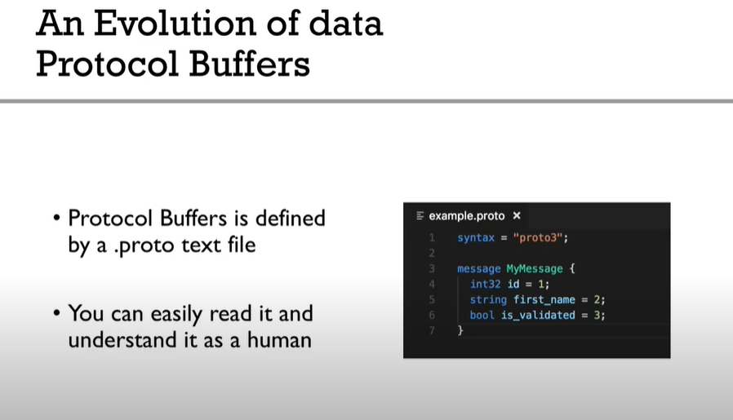

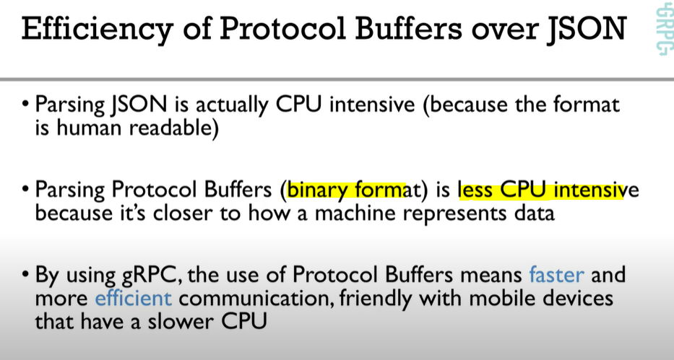



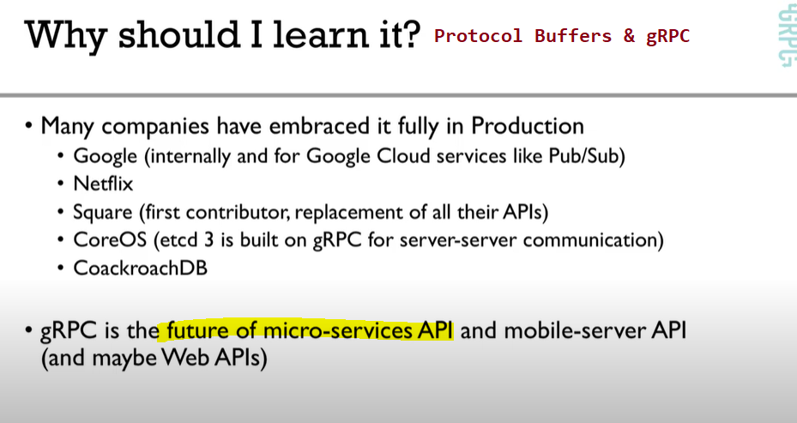

# gRPC:

<https://www.youtube.com/watch?v=XRXTsQwyZSU>

Building MS requires lot many things to think over:

* Data Formats
* Error Patterns
* Think about data model (JSON/XML/Binary)
* EndPoints
* Load Balancing
* Efficiency
* Latency
* Interoperability
* Authentication/Authorization
* Logging
* Token Based
* Scalablity etc etc.

**To avoid these all hassles, gRPC helps you.**

